Sponsors and Exhibitors
List in their tiers as confirmed
Link Prospectus as a downloadable

 |  | 

Venue (Sydney ICC)
ICC Address- 14 Darling Dr, Sydney NSW 2000
Situated at the intersection of Sydney’s academic, cultural and technology precincts, International Convention Centre Sydney (ICC Sydney) affords delegates, exhibitors and visitors convenient access to Australia’s most cosmopolitan city. The emerging financial, dining and retail precinct of Barangaroo is nearby; there are numerous galleries, theatres and concert halls within easy reach; and the bustling city centre is only a short walk away.
ICC Sydney is easily accessible by public transport, including light rail, ferry and train and is only a 10-minute walk from Central and Town Hall train stations. Secure parking is available and conveniently located within the Darling Harbour precinct.
See information on ICC Sydney accessibility here: Transport & Parking Options | Getting Here | ICC Sydney.
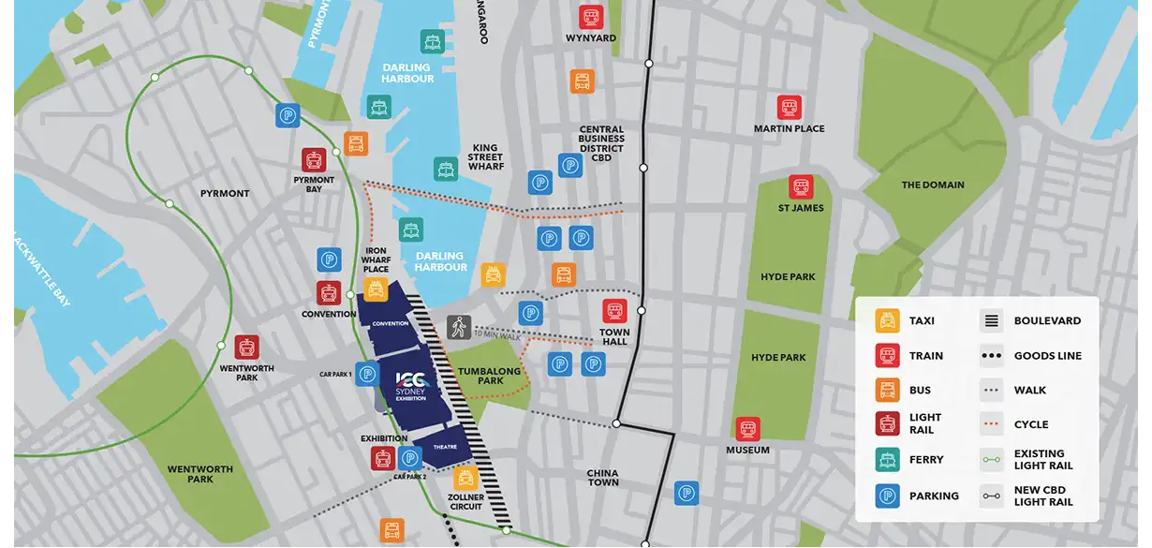

Visit Sydney

Sydney Opera House Precinct
- Explore the world-famous Sydney Opera House and its vibrant surrounds. Wander the scenic harbourfront, dine at exceptional waterside restaurants or take in a show. With stunning views and buzzing atmosphere, this iconic spot is a must-see, just a short stroll from Circular Quay and the CBD.

Sydney Harbour Bridge
- Climb it, walk it or admire it from below – the Sydney Harbour Bridge is a true Aussie icon. For unforgettable views, take the BridgeClimb or simply stroll across for panoramic harbour and cityscapes. It’s a bucket-list moment that captures the heart of Sydney.

The Rocks
- Step back in time at The Rocks, Sydney’s historic heart. Discover cobbled laneways, heritage pubs, lively markets and cultural attractions. With its mix of colonial charm and modern flair, it’s the perfect place to grab a bite, enjoy a drink, or uncover Sydney’s fascinating past.

Botanical Garden
- Escape to nature at the Royal Botanic Garden Sydney, a peaceful oasis in the heart of the city. Stroll through themed gardens, discover native flora, and enjoy sweeping harbour views. Perfect for a picnic or relaxed afternoon walk, it’s a beautiful place to recharge.

Chinatown
- Experience the flavours, sights and culture of Sydney’s Chinatown. Located in Haymarket, this bustling precinct is packed with authentic Asian eateries, markets, bubble tea shops and hidden gems. A feast for the senses, it’s perfect for a casual bite or a night-time wander.

Amazing Australia
Australia often evokes images of golden beaches, outback landscapes, quirky creatures and unique experiences, but that’s just the beginning.
While you are here for RSS2026 we encourage you to take the chance to visit some of the amazing sites that Australia has to offer. From sweeping sand dunes, to tropical rainforests, to bushland creatures and turquoise coastlines filled with wonder, there is sure to be something for everyone here.

Transport
Sydney (Kingsford Smith) International Airport (SYD) is one of the busiest airports in Australia and one of the world’s oldest continuously operated commercial airports.
Sydney Airport handles hundreds of flights daily, from numerous cities around the world. Major international hubs such as Singapore, Dubai, Los Angeles, Hong Kong and various cities in Europe are common departure points for flights to Sydney.
ICC Sydney - 14 Darling Drive, Sydney, NSW 2000
ICC Accessibility

Get to the ICC Sydney from the airport
The Sydney airport is 8kms from ICC Sydney, with an average drive time of 25 minutes. Taxis and trains are available to and from the airport. You can plan your trip via Transport NSW here.

Getting around Sydney
Sydney has an extensive public transport system of buses, trains, metro rail, light rail and ferries. To use the network, you’ll need to either purchase an Opal card or use a contactless credit card, debit card or mobile device.
- Use an Opal card or your preferred payment method on public transport services in Sydney, the Blue Mountains, Central Coast, Hunter Valley, Illawarra and the Southern Highlands.
- Purchase an Opal card and load it with funds at participating retailers such as newsagents, convenience stores and supermarkets, and at Sydney Airport. There are also top-up machines at some train stations, light rail stops and ferry wharves.
- Tap your Opal card on the reader when you board your selected mode of transport and be sure to tap the reader again when you disembark.
- The Sydney Trains Network covers Sydney metropolitan area train services bounded by Berowra to the north, Bondi Junction to the east, Waterfall to the south, Macarthur and Leppington to the south west, Emu Plains and Richmond to the west.
Visit the Transport NSW website for more information about how to get around with Sydney Transport.

Transport updates
Please check the transport NSW travel alerts for details of any changes to transport services to ICC Sydney.
For any Light Rail updates, please click here.

Visa

Letters of Invitation for visa applications
Please complete your RSS Conference registration online to receive your letter of invitation. Invitations will be issued automatically as part of the registration confirmation process once full payment has been confirmed.

Visa options for conferences
All visitors to Australia must have a valid visa to travel to and enter Australia (other than New Zealand passport holders who will normally be granted a Special Category visa on arrival, provided they meet health and character requirements; and permanent residents of Norfolk Island who may be granted a Permanent Resident of Norfolk Island visa on arrival).
If you are planning to visit Australia for a business event such as a conference, trade fair, seminar or expo, there may be different visa options available to you. The appropriate visa will depend, amongst other things, on your purpose for visiting Australia.
To explore visa options and get information on visas appropriate for you, visit the Department of Home Affairs website and answer a few short questions.

Visa options
Participants, attendees and speakers that will not be working, performing or otherwise be paid to contribute at the event may be eligible to apply for the following visa options:
- Visitor (subclass 600)(Business stream) visa. For more information see: https://immi.homeaffairs.gov.au/visas/getting-a-visa/visa-listing/visitor-600/business-visitor-stream
- Electronic Travel Authority – ETA (subclass 601). For eligible passport holders and more information see: https://immi.homeaffairs.gov.au/visas/getting-a-visa/visa-listing/electronic-travel-authority-601
- eVisitor (subclass 651)(Business Stream) visa. For eligible passport holders and more information see: https://immi.homeaffairs.gov.au/visas/getting-a-visa/visa-listing/evisitor-651
Participants including speakers, exhibitors and other contributors that will be working, or otherwise be paid to contribute at the event may be eligible to apply for one of the following visa options:
- Temporary Activity (subclass 408)(Invited Participant) visa (where there is an inviting Australian organisation). For more information see: https://immi.homeaffairs.gov.au/visas/getting-a-visa/visa-listing/temporary-activity-408/invited-for-other-social-and-cultural-activity
Please note that a letter of support from an Australian organisation is a legislative requirement for the Temporary Activity (subclass 408)(Invited Participant) visa.
- Temporary Work (subclass 400)(Short Stay Specialist) visa (where there is no inviting Australian organisation). For more information see: https://immi.homeaffairs.gov.au/visas/getting-a-visa/visa-listing/temporary-work-400

Invitation and registration to attend the event
Although this is a separate process to lodging your visa application, when assessing whether you meet the criteria for the grant of a visa, the department may take into account whether you are registered or were invited to attend the event.
Confirmation of registration, or a copy of your letter of invitation, should accompany visa applications. For online subclass 400 and subclass 600 applications, information about documents that need to be attached will be provided as part of the application process.
To request a letter of invitation please contact the secretariat.

Visa Application Process and Processing Times
- Whether the applicant has lodged a complete application, including all necessary supporting documents and paid associated visa application charges (if applicable)
- How promptly the applicant responds to any requests, if required, for additional information
- How long it takes to perform any required checks on the supporting information provided
- How long it takes to receive information from external agencies, particularly in relation to health, character, and national security requirements (if required)
- When the application is lodged taking the current global visa processing times into account
- More information about visa processing times please see: https://immi.homeaffairs.gov.au/visas/getting-a-visa/visa-processing-times/overview
For this reason, we would advise that visa applications be lodged at least 4 to 6 weeks prior to a person’s intended date of travel.

Things to Consider before Lodging an application

Entering and Leaving Australia
Travellers should familiarise themselves with Australia’s border and entry requirements. For further information, see ‘Entering and leaving Australia’ at: https://www.homeaffairs.gov.au/covid19/entering-and-leaving-australia

Biometrics
Visa applicants outside of Australia will need to provide biometrics when they apply for a visa that is part of the Australian biometrics program, or where they are from a country, or located in a country at time of application that is part of the Australian biometrics program.
For information regarding Australia’s biometric program including visas and countries that are part of the program, please see: https://immi.homeaffairs.gov.au/help-support/meeting-our-requirements/biometrics

Contact us

We are here to help
For all general enquiries, please contact the Workshop Secretariat.

General Enquiries
Rebekah McIntosh
rss-info@icmsaust.com.au

Program and Abstract Enquiry
Insert RSS Email

Registration, Visa and Accommodation Enquiry
Genevieve Trollope
rssconference.info@gmail.com

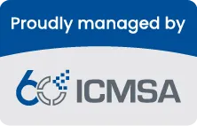 | ICMS Australasia  +61 (2) 9254 5000  icmsaust.com.au  234 George Street, Sydney  NSW, 2000  Australia

